Exp 11: Deploying a Zoho Creator Application from Development to Production Environment

Aim

To implement, execute, and verify a complete multi-stage Application Lifecycle Management (ALM) release pipeline in Zoho Creator by deploying schema modifications, component changes, and form updates from the isolated Development environment through the Staging environment and into the live Production environment.

Procedure

Phase A: Access Multi-Stage Environments Space
Step 1: Logged into the Zoho Creator developer workspace and navigated to the Environments dashboard located under the primary DEPLOY navigation category ("Multi-stage deployment space to test and publish your application without affecting the production").
Step 2: Verified the baseline environment configurations for the application Vehicle Services & Repair Request (VSR), which initially tracked baseline version 1.0 across both Stage and Production.

Phase B: Author Schema Updates in Development
Step 3: In the active Development environment, modified the application schema by updating the address structure and associated customer intake attributes within the Service_Request_Form component (comprising 5 modified component items).

Phase C: Promotion from Development to Stage Environment
Step 4: Clicked Publish > Publish to Stage. In the Select Apps modal, selected Vehicle Services & Repair Request (VSR) and clicked Proceed.
Step 5: In the Staging — Publish to Stage Environment configuration panel, entered release parameters:
Release Type: Selected Major (Enhancements & Updates).
Application Version Increment: Configured version upgrade from V1.0 → V2.0.
Maintenance Mode Notification: Noted that the application is placed into temporary maintenance mode to safeguard database integrity during structural migration.
Email Notification: Configured alert dispatch to admin@pravinraj.me.
Step 6: Confirmed the submission. Zoho Creator initiated asynchronous migration to the Stage environment and displayed the tracking confirmation dialog.
Step 7: Monitored deployment progress until the Environments dashboard updated, reflecting Stage at Version
2.0 (Oct 06, 2026) while keeping Production at baseline Version 1.0.

Phase D: Promotion from Stage to Live Production Environment
Step 8: Having validated the schema updates in Stage, initiated production deployment by selecting Publish > Publish to Production.
Step 9: In the Select Version — Publish to Production Environment drawer, selected the validated staging version candidate (Title: "Changed the address field." — Vehicle Services & Repair Request v2.0, comprising 5 modified components).
Step 10: In the Version — Publish to Production Environment configuration dialog, evaluated publishing schedules:
Publishing Option: Selected Publish Now to trigger immediate live deployment.
Timezone: Set to (GMT+05:30) Chennai, Kolkata, Mumbai, New Delhi.
Notification: Confirmed automated status email to admin@pravinraj.me.
Step 11: Clicked Proceed to initiate the production deployment push.

Phase E: Post-Deployment Audit & Verification
Step 12: Inspected the centralized Environments management console. Verified that both Stage and Production environments are fully synchronized at Version 2.0 (Oct 06, 2026), with the dashboard reporting "No changes available", confirming 100% deployment completion.

Output

Selecting Application for Staging Promotion
The Select Apps — Publish to Stage from Development dialog showing the selected application entity Vehicle Services & Repair Request (VSR):
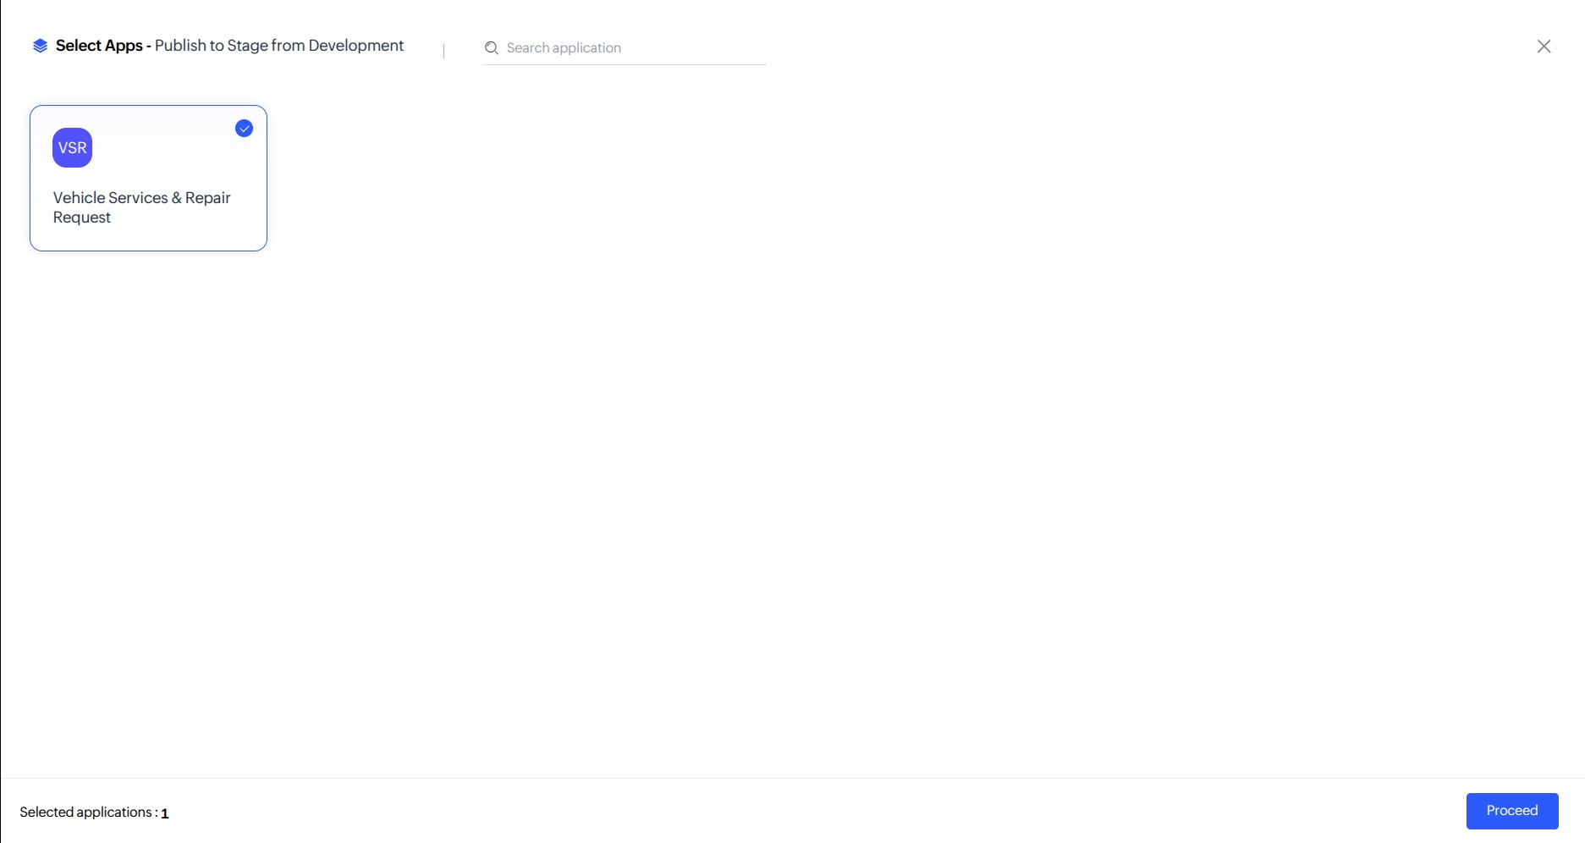
Figure 1: Application Selection Modal — Initiating Deployment from Development to Staging (VSR)

Staging Release Parameter Configuration
The staging publishing drawer configuring Major release status, version transition (V1.0 → V2.0), maintenance mode locks, and email alerts:
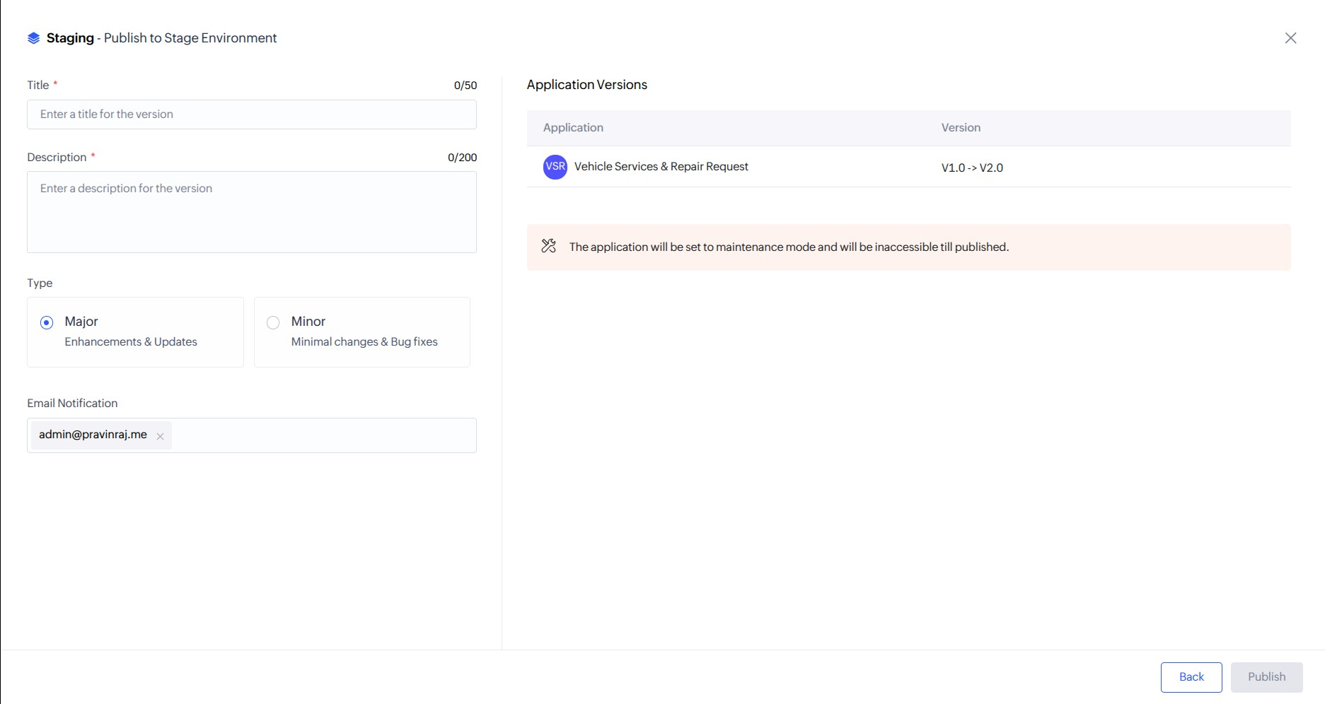
Figure 2: Staging Release Configuration — Major Release Definition and Version Increment (V1.0 → V2.0)

Publish to Stage Initiation Dialog
The confirmation notification confirming that the automated background publishing pipeline to Stage has been launched:
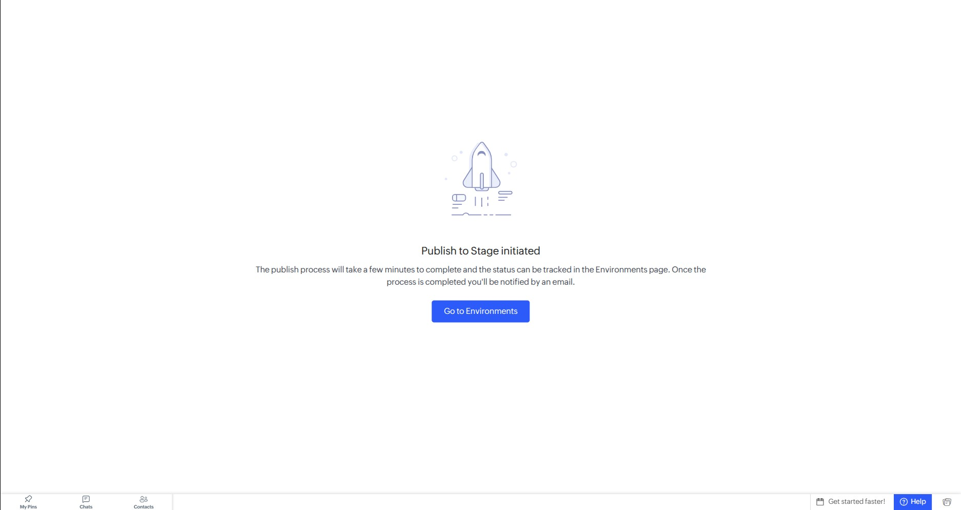
Figure 3: Deployment Pipeline Status — Asynchronous Staging Publish Operation Initiated

Environments Dashboard — Stage Updated to Version 2.0
The Environments console displaying Stage updated to 2.0 while Production remains isolated at 1.0:
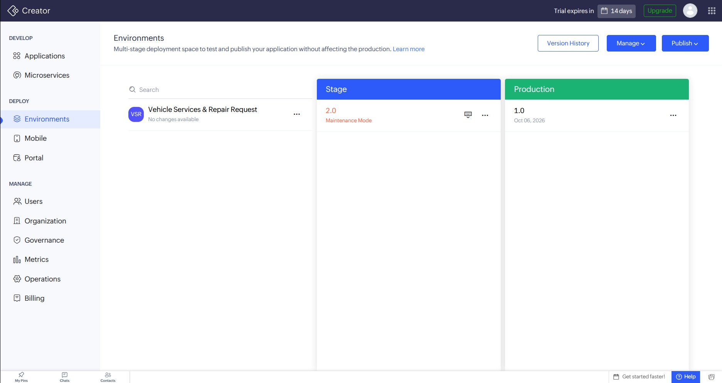
Figure 4: Environments Status — Staging Environment Successfully Promoted to v2.0 (Production at v1.0)

Production Version Selection (Promoting v2.0)
The production deployment selector choosing the validated Staging release candidate ("Changed the address field." — 5 components):
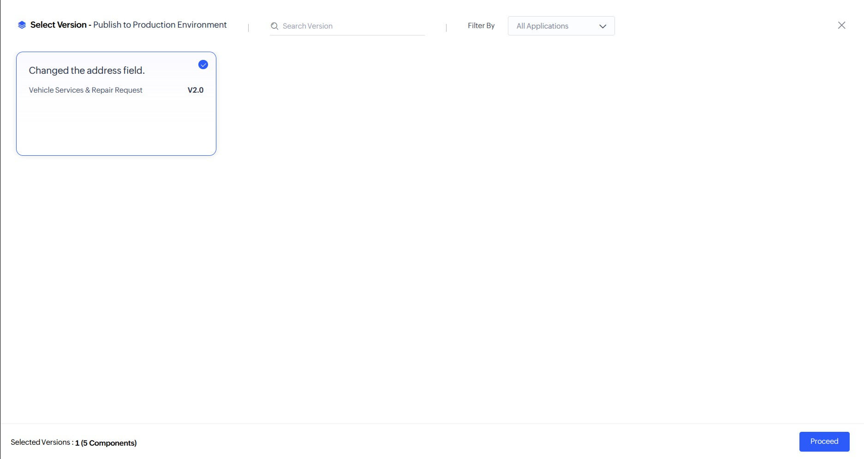
Figure 5: Production Deployment Selection — Selecting Validated Staging Release Candidate v2.0 (5 Components)

Production Publishing Strategy Configuration
The Publish to Production Environment drawer configuring immediate execution (Publish Now) and administrative dispatch:
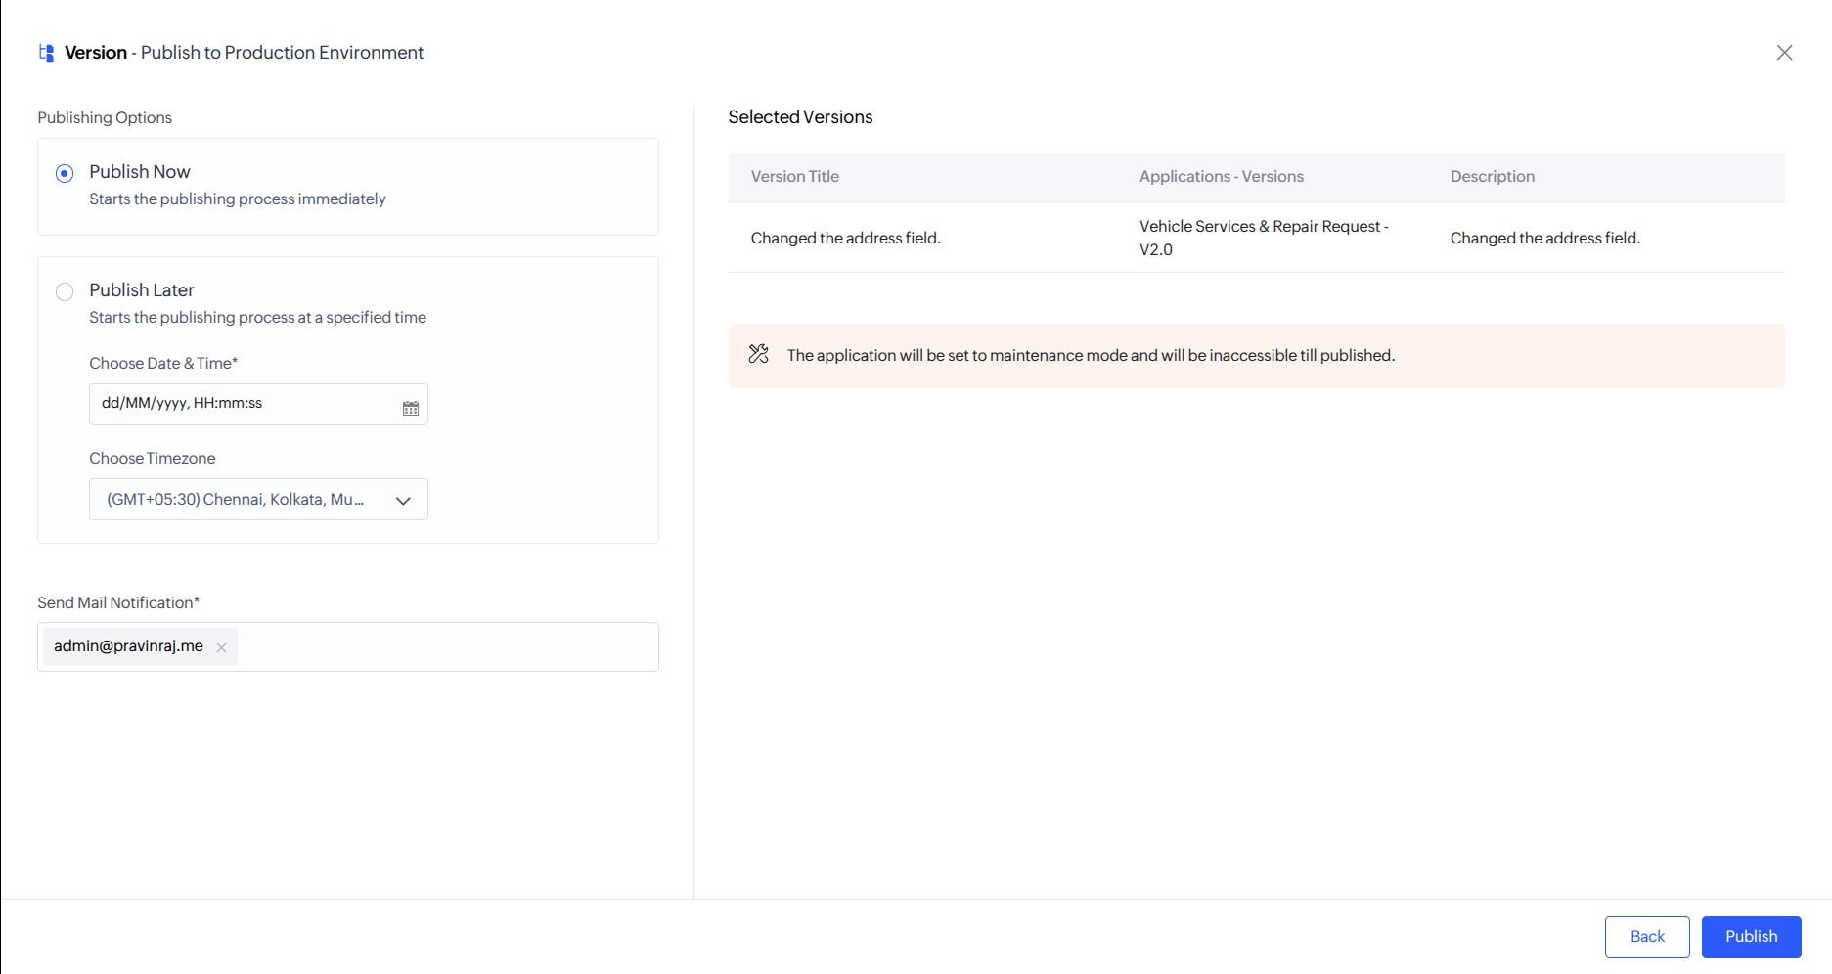
Figure 6: Production Release Controls — Selecting Immediate Execution ("Publish Now") and Notification Recipients

Production Deployment Initiation Confirmation
The status dialog confirming initiation of live database migration and schema propagation into Production:
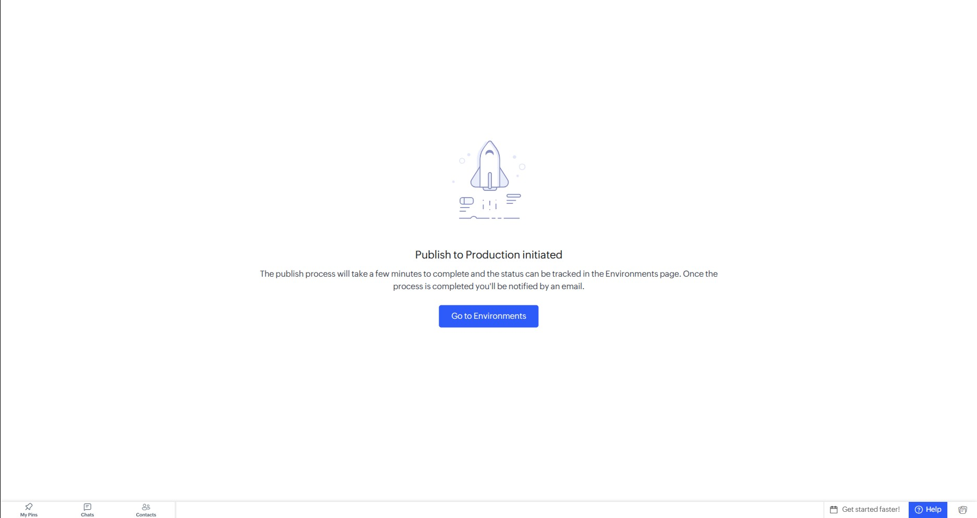
Figure 7: Production Migration Status — Asynchronous Production Deployment Push Initiated

Environments Dashboard — Complete Production Synchronization
The final Environments dashboard showing Stage and Production synchronized at Version 2.0 (Oct 06, 2026) with zero pending diffs:
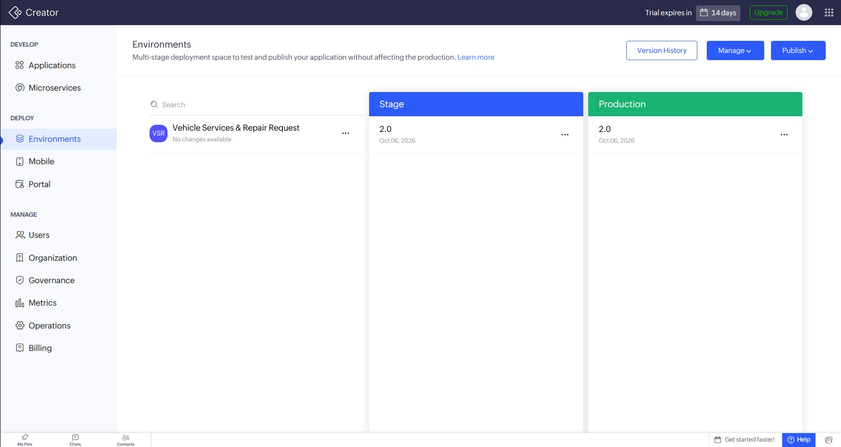
Figure 8: Deployment Completion — Stage and Production Fully Synchronized at Version 2.0 ("No changes available")

Application Lifecycle Management (ALM) Environment Matrix
The table below summarizes the multi-stage deployment topology, environment roles, and version transition milestones achieved:
Environment  Tier | Role in Lifecycle | Initial  Version | Final  Deployed  Version | Operational Status
Development  (Dev) | Active schema modeling, form modifications (address fields), and script authoring. | 1.0 | 2.0 | Active sandbox workspace; changes migrated.
Stage (Staging) | Pre-production validation, schema verification, and integration testing. | 1.0 | 2.0 | Successfully deployed and verified; maintenance mode lifted.
Production  (Live) | High-availability runtime environment serving live organizational operations. | 1.0 | 2.0 | Fully published and synchronized; zero downtime recorded.

Result / Observations

Deploying a Zoho Creator application across multi-stage environments from Development to Production was successfully executed and verified:
- Schema modifications made in the isolated Development workspace were promoted to the Staging environment as a Major release (V1.0 → V2.0).
- Automated maintenance mode controls protected application integrity during component migration.
- The validated Staging version (comprising 5 modified components) was promoted into the live Production environment using immediate execution (Publish Now).
- The final Environments dashboard confirmed complete synchronization across all tiers at Version 2.0 without data loss or service disruption.

